WD2002SJ (LTC3780) Voltage/Current regulator

Constant current/Undervoltage protection board

This is a rough translation of the Datasheet (in Chinese) for the WD2002SJ board that is marketed online as the ["LTC3780 Automatic lifting pressure constant voltage step up step down 10A 130W"](http://www.ebay.com/sch/LTC3780+Automatic+lifting+pressure). It is a fairly well designed DC-DC switcher based on Linear's [LTC3780 - High Efficiency, Synchronous, 4-Switch Buck-Boost Controller](http://www.linear.com/product/LTC3780).

This module is capable of providing a stable output voltage when the input voltage is less than, greater than or equal to the desired output voltage. For example an output voltage of 12V can be achieved when the input voltage is anywhere between 5-32V.

The module also contains a circuit to trigger an automatic power down when the input voltage reaches a pre-defined cut-off. (Useful to protect batteries from running down)

The module is capable of the following functions:

* Constant voltage output
* Constant current output
* Under-voltage protection

It has the following protections built in:

* Output fault LED
* Output over-current protection
* Over voltage protection
* Short circuit protection

This board can be used for various applications including as a charging circuit, a high power LED driver, equipment/automotive power supply etc.

# Electrical parameters:

* Input voltage: DC 5 – 32V (>10V is recommended)
* Output voltage: DC 1- 30V continuously adjustable. Boards ships with 12V as default
* Output current: 10A max, 7A sustained. Board ships with 4A as default.
* Output Power: 80W sustained, 10W peak. If output power exceeds 80W enhanced heat dissipation is required
* Output ripple: 50mV – measured at 12V switching to 12V, 5A.
* Input reverse polarity protection: None. If necessary place a Schottky diode in series on the input.
* Output reverse polarity protection: None. If necessary place a Schottky diode in series on the output.
* Short circuit protection: Yes
* Operating temperature range: -45ºC to +85ºC
* Dimensions: 77.6mm x 46.5mm x 15mm

# Mounting

* If mounting cabinet is made of metal, mount to 4x 3mm metal standoffs. Let the metal heat sink touch the chasis – it will help with heat dissipation
* If mounting within an enclosure, make sure adequate ventilation is provided.

# Application methods:

1. Battery under-voltage protection:

To set a 12V lead acid battery with 10V under voltage protection, connect the input terminals of the board to a 10V regulated power supply and adjust the Under-voltage regulation potentiometer (refer to diagram below) till the red Fault indicator LED turns on. Now when the 12V battery is connected the in-built under-voltage protection circuit will kick in and cut off the power supply when the voltage hits 10V.

1. Output voltage adjustment:

Connect the power input (voltage must be greater than the under-voltage protection value). Connect the output terminals to a multimeter and adjust the output voltage potentiometer (refer to diagram below) till the required voltage is reached.

1. Output current adjustment:

Connect power to the input terminals. Connect load to the output terminals. Connect an ammeter on the output terminals to measure the current (make sure it is rated for >15A so it doesn’t accidentally burn out). Measure the current output while adjusting the output current potentiometer till the required current is being output. Remove the ammeter. Remember, the maximum operating power of this board is 130W in bursts and 80W for extended periods of time. Please make sure these limits are adhered to.

Note 1: If used as a constant voltage device, set the output current to maximum

Note 2: The normal LED is blue. If the red fault LED comes on, it indicates one of the following faults has occured:

* Input voltage is low
* Output current is too high
* Output short circuit
* 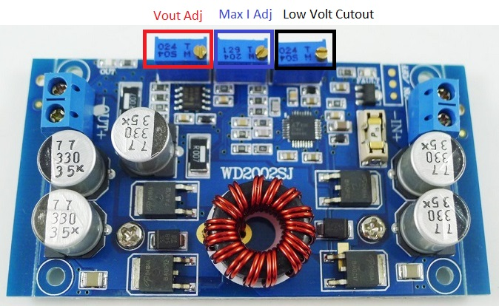

This document is distributed in the hope that it will be useful, but WITHOUT ANY WARRANTY; without even the implied warranty of MERCHANTABILITY or FITNESS FOR A PARTICULAR PURPOSE.